**Use INCLUDE TEXT in adobe forms**

1. Create a Standard text named ZRT in tcode So10 .Add the below line in the text

zyny_standard_text

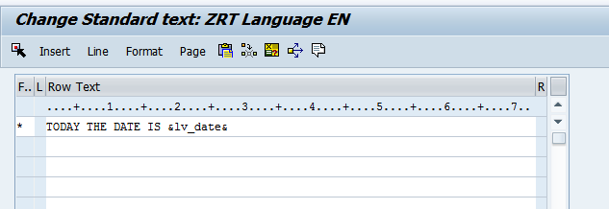

1. Go to T code SFP. Create an interface and then create a form (For details ,please refer the previous demos)

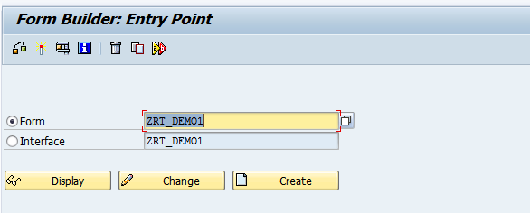

1. In the interface, create a global variable LV_DATE.

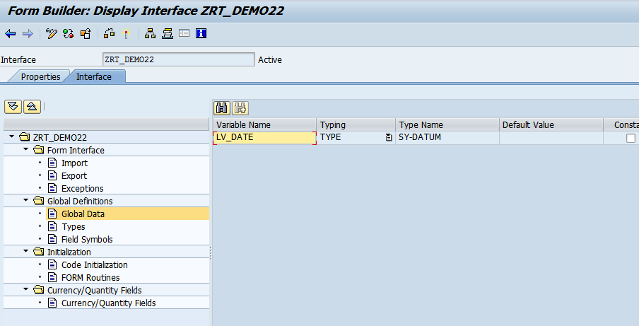

1. In the Initialisation, write the below code.

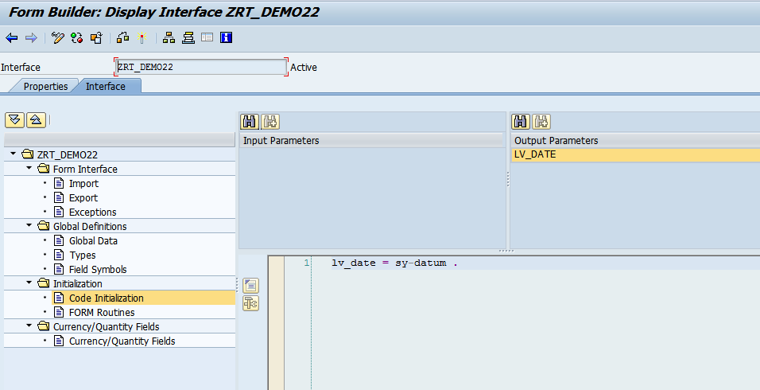

1. Open the Form. In the context window, create TEXT node as shown below.

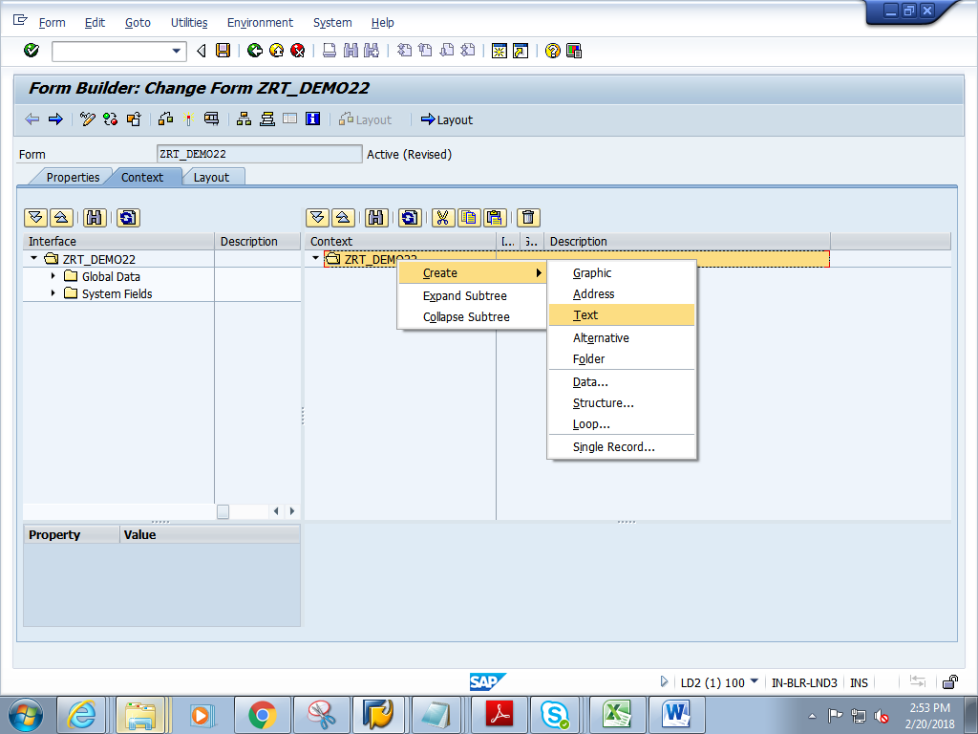

1. Change Text Type to INCLUDE TEXT and press enter

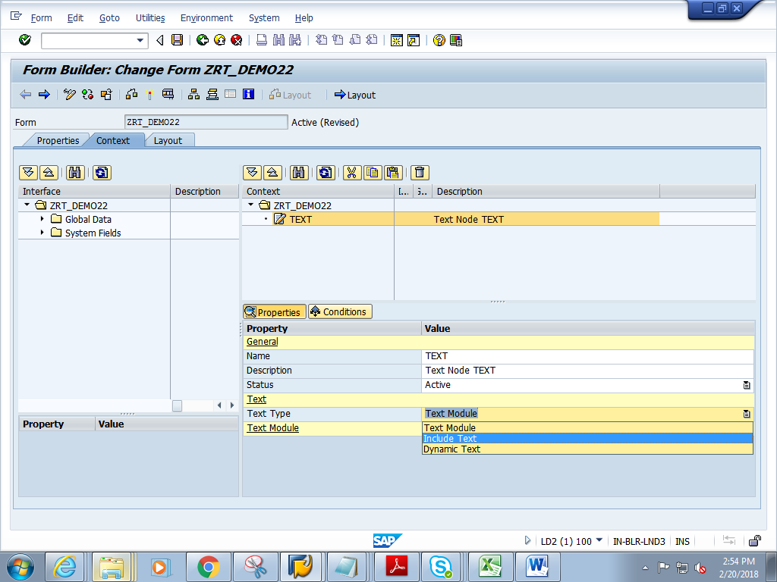

1. Press f4 on TEXT NAME

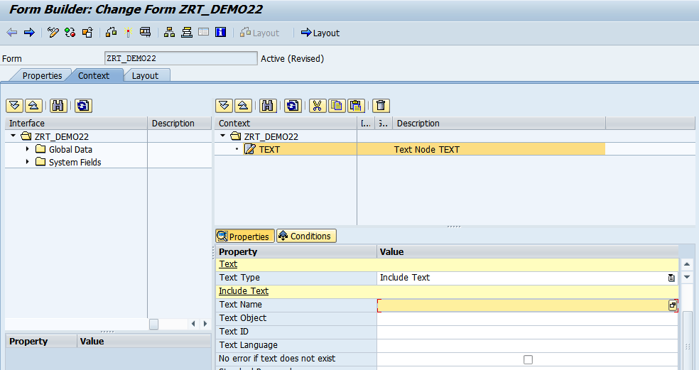

1. Give the TEXT name as **ZRT**(created in So10) and click on continue

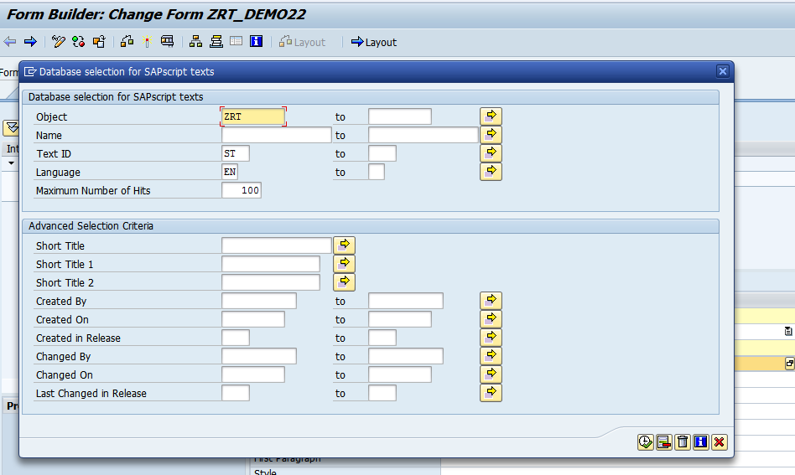

1. The fields under Include Text get populated

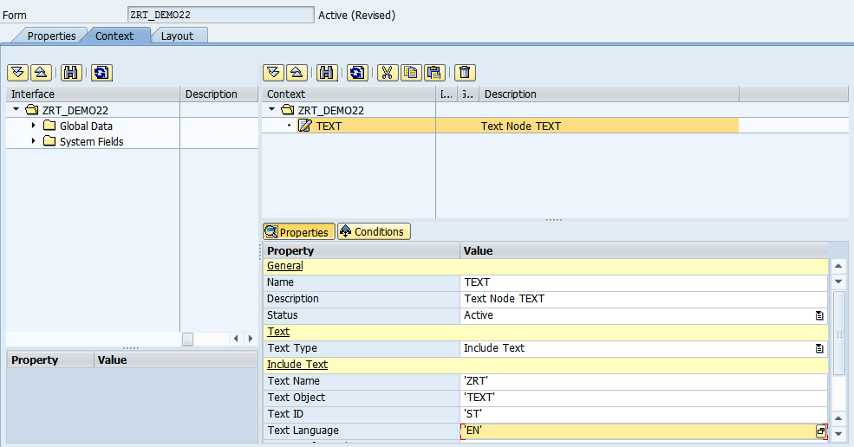

1. Drag and drop the lv_date from Global Data to Context

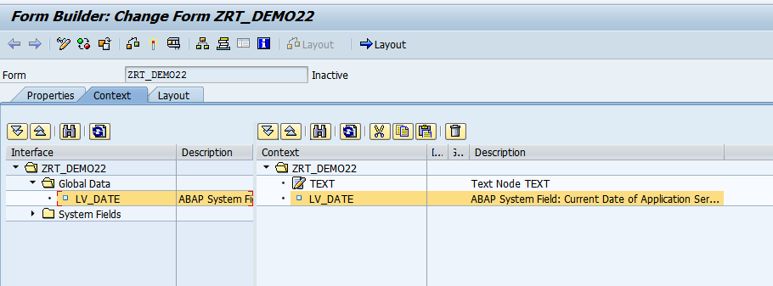

1. Save and click on Layout
2. In the Layout, drag and drop Text from Hierarchy to the Design view.

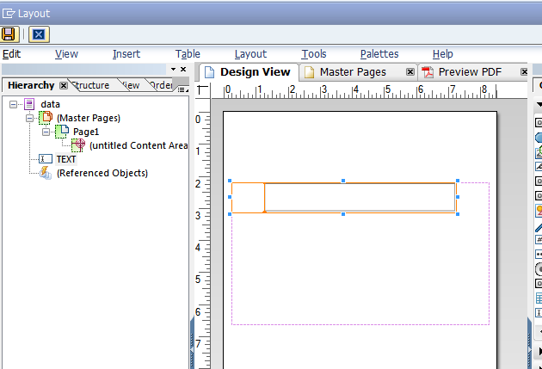

1. Save and close Layout.
2. Click on context. Save and activate the form
3. Execute the form .Execute the function module

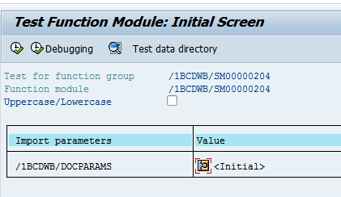

1. Click on Print preview

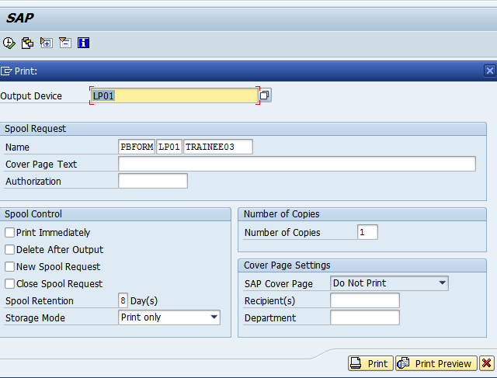

1. Expected output is as follows.

